**UNIVERSITY OF ENERGY AND NATURAL RESOURCES, SUNYANI**

**SCHOOL OF SCIENCES**

**DEPARTMENT OF INFORMATION TECHNOLOGY AND DECISION SCIENCES**



**PROJECT REPORT**

**TOPIC**

Design And Implementation of a Web Platform for Enhancing Blood Donation and Supply Chain Management in Ghana

**SUBMITTED BY**

APPIAGYEI YAW KONADU ANTWI - UED2704322.

ASAMOAH AGYEMANG SOLOMON - UED2702622.

SONKPI EVARASTUS - UED2703722

Submitted in partial fulfillment of the requirement for the award of a

Diploma in Information Technology

**DECLARATION**

Appiagyei Yaw Konadu Antwi, Asamoah Agyemang Solomon, and Sonkpi Evarastus wish to state that this research study was collectively undertaken and written by us. We hereby declare that all sources of information helpful in the compilation of this study have been sourced and acknowledged. It is our full responsibility to observe with strict adherence or accept the consequences of any event that falls under the policies on research ethics of the university.

APPIAGYEI YAW KONADU ANTWI **…………………… ……………………..**

(UED2704322) SIGNATURE DATE

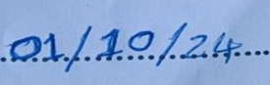

ASAMOAH AGYEMANG SOLOMON **…………………… ……………………**

(UED2702622) SIGNATURE DATE



SONKPI EVARASTUS **…………………… ……………………**

 (UED2703722) SIGNATURE DATE



MR. MICHAEL OPOKU **…………………….. ……………………**

 (SUPERVISOR) SIGNATURE DATE

PROF.DR. PETER APPIAHENE **…………………….. ....…………………**

(HEAD OF DEPARTMENT) SIGNATURE DATE

**DEDICATION**

This project is for all of the healthcare professionals that work to Save Lives every day and for all of the selfless blood donors that make daily life improving donations. I also want to dedicate to my family and friends for the strong support and encourage that were essential to my journey.

**ACKNOWLEDGMENT**

We would like to extend our heartfelt appreciation and thanks to all the people that has helped to complete the web platform for Ghana blood donation and supply chain management platform. All of this has been valuable with your support.

Also we are grateful to Mr. Michael Opoku for the positive encouragement, very sound advice and most importantly the professional guide he has given us in this project which he has supervised for us.

We want to also thank our department head Dr. Peter Appiahene for your mentorship which helped us navigate this project.

I would also like to express my heartily appreciation to my colleagues and peer collegues who participated in this research and gave valuable advices on the advice to this research.

We would also like to thank everyone who has directly shaped this project. Without you and the background people who may go unremembered but did play a large role, this project would not have been possible. I appreciate you being part of this journey.

**ABSTRACT**

Healthcare depends on blood donation to help save countless patients with life-saving blood. Nevertheless, in Ghana the process has several impediments thereby being characterized by poor donor turnout, information deficit, and poor supervisory management of the blood supply chain. These problems cause extreme shortage of blood in the hospitals, leading to life danger. First, these challenges are addressed by this project, which involves the design and implementation of a web platform to improve blood donation and blood supply chain management in Ghana. Donors will be able to sign up easily, make apptoointments and follow up on their donation, hospitals will be able to request different blood types in real time. Improved inventory management coordination with hospitals will derive benefits for the Ghana Blood Bank. Further, the platform will have an educational module which aims at spreading public awareness about blood donation. It is the expected outcome that blood donation process that leads to a streamlined, efficient, and reliable blood donation process which creates room for efficient healthcare delivery in Ghana.

Table of Contents

LIST OF FIGURES……………………………………………………………………………………………………………………...viii

LIST OF INTERFACE IMAGES……………………………………………………………………………………………………………………ix

LIST OF TABLES……………………………………………………………………………………………………………………………….…….…x

DECLARATIONii

DEDICATIONiii

ACKNOWLEDGEMENTiv

ABSTRACTv

**CHAPTER 1**1

1.0 INTRODUCTION1

1.1 PROBLEM STATEMENT2

1.2 MAIN OBJECTIVE3

1.3 SPECIFIC OBJECTIVE3

1.4 SCOPE OF THE PROJECT3

1.5 RESEARCH QUESTION6

**CHAPTER 27**

2.0 INTRODUCTION7

2.1 IMPORTANCE OF BLOOD DONATION AND SUPPLY CHAIN MANAGEMENT7

2.2 CHALLENGES IN EXISTING BLOOD DONATION SYSTEMS IN GHANA7

2.3 ANALYSIS OF EXISTING SYSTEM8

2.4 GAPS IN CURRENT SYSTEMS9

2.5 PROPOSED SOLUTION FOR A COMPREHENSIVE WEB PLATFORM 9

2.6 CCONCLUSION10

**CHAPTER 3**11

3.0 INTRODUCTION11

3.1 AGILE DEVELOPMENT PLAN11

3.2 METHODS AND TOOLS13

3.3 SYSTEM DESIGN 14

3.4 AGILE DEVELOPMENT PROCESS17

3.5 TECHNOLOGY STACK19

3.6 TESTING AND QUALITY ASSURANCE 19

3.7 DEPLOYMENT20

3.8 MAINTENANCE AND FUTURE ENHANCEMENTS20

3.9 TOOLS AND TECHNOLOGIES20

**CHAPTER 4**21

4.0 INTRODUCTION21

4.1 HOME PAGE OVERVIEW21

**CHAPTER 5**38

5.0 INTRODUCTION38

5.1 RECOMMENDATIONS38

5.2 CONLUSION40

REFERENCES41

LIST OF FIGURES

Figure 1 Agile Development Methodology12

Figure 2 System Design Of The Blood Bank System14

LIST OF INTERFACE IMAGES

Image 1 Quick Navigation Section22

Image 2 Statistics Section23

Image 3 Blood Donation Banner 123

Image 4 Blood Donation Banner 224

Image 5 Blood Donation Banner 324

Image 6 About Us Section25

Image 7 Our Service Section26

Image 8 Donate Now Section27

Image 9 Footer Section28

Image 10 Banner Section28

Image 11 Benefits Section29

Image 12 Registration Form Section30

Image 13 News Section31

Image 14 Book Appointment Form32

Image 15 Blood Stock Preview33

Image 16 Request Blood Form33

Image 17 Educational Resource Section34

Image 18 Blood Store Section35

Image 19 Contact Us Page 36

LIST OF TABLES

Table 1 Donor Table15

Table 2 Appointment Table15

Table 3 Blood Request Table16

**CHAPTER 1**

**1.0 INTRODUCTION**

It is extremely important to donate blood to the healthcare, a means which provides crucial lifeline to many patients in the need of medical attention. According to the World Health Organisation (2020). In Ghana blood donation deserves attention since the country is facing low donor turnout as a result of the October outline, not to mention poor information dissemination. (Agyeman & Osei, 2019). Where these challenges rise up, they lead to significant deficits in blood at hospitals which slows down and limits effective treatment. (Ghana Health Service, 2021).

Furthermore, it becomes even challenging to undertake because there is no central place to coordinate the incoming blood supply and outgoing demands. This problem disrupts and makes it difficult to ensure that the right blood types are available in emergency cases (Kyeremeh & Adjei, 2018). Consequently, in the existing blood donation and supply management systems in Ghana, Traditional technology is characterized by manual flow of work with high incidences of errors and inefficiencies (Osei-Akoto & Owusu-Agyei, 2020). Donors also find it a challenge to access details regarding the donation centres and arrangements of appointments. Currently, it is not easy for blood banks to get clear blood requirements from hospitals, which leads to prolonged distribution (Ghana Health Service, 2021).

The purpose of this project is to design and implement an elaborate website to increase the blood donation and availability in Ghana. From the platform, the donors get easy ways to open accounts and schedule appointments apart from getting notifications of their progress in donating. The platform will allow hospitals to make direct calls for accurate blood typing all at once, and enhance the bond between the Ghana Blood Bank (Kyeremeh & Adjei, 2018). A teaching factor will also be included to ensure the public gains increased understanding of the need for more blood donations and to increase the engagement from the community (Osei-Akoto & Owusu-Agyei, 2020).

It is expected that introduction of this web platform will result in improve the effectiveness of managing blood supply and informing the blood donor community. This project aims at employing technology to enhance a stable and sustained blood inventory that would enhance health outcomes in Ghana (Agyeman & Osei, 2019; World Health Organization, 2020).

**1.1 PROBLEM STATEMENT**

Ghana’s blood donation and distribution system has a lot of problems such as inefficiency and poor coordination (Ghana Health Service, 2021). The poor contribution of donors has made it hard for blood banks to have stable blood supplies; and hospitals have problems quickly accessing relevant blood types for their patients (Agyeman & Osei, 2019). Moreover, there are no known mechanisms for teaching the public the significance of frequent blood giving and the resultant low donation rates (Kyeremeh & Adjei, 2018). These problems have therefore led to critical shortages and unmananged delays (Osei-Akoto & Owusu-Agyei, 2020) for patients at risk. Worldwide there is an increasing demand for technology that improves blood donation operations and strengthens relationships among donors and medical institutions while increasing public sharing of the need for blood donation (World Health Organization, 2020). The objective of this initiative is to aim to build an extensive web interface to help solving these problems and engaging donors in Ghana.

**1.2 MAIN OBJECTIVE**

Develop and deploy an online platform that helps donors schedule giving and providing blood helps hospitals obtain blood from the Ghana Blood Bank while enhancing public understanding of blood donation importance.

**1.3 SPECIFIC OBJECTIVE**

1. Creating an easy-to-use web application for upcoming donors to sign up quickly and follow their donation efforts.

2. Formulating an effective strategy for hospitals to find specific blood types in close by locations for better resource administration.

3. Adding a communication channel will improve teamwork between donor hospitals and the Ghana Blood Bank.

4. Introducing a teaching feature in the web application to raise public awareness about the benefits of blood donation as well as the conditions for donating.

**1.4 SCOPE OF THE PROJECT**

This project tackles the following key areas which are under the scope of this project:

**1.4.1 TARGET USERS**

**Blood Donors:** This is the place, where you hope to find people who want to give blood away. It allows them to sign up, set an appointment, see their history of donations and even get information regarding their dates for future donations.

**Hospitals:** Hospitals will employ the platform to request certain types of blood, control their bloodstock needs, and work with the Ghana Blood Bank on the delivery on time.

**Ghana Blood Bank:** The platform will assist the Ghana Blood Bank in operational activities of blood donation, stock management and distribution of blood resources to hospitals nationwide.

**1.4.2 FUNCTIONAL MODULES**

**Donor Registration and Management:** Donor registration, personal information entry, donation eligibility verification & donor donation activities oversight are thus offered by an intuitive module.

**Appointment Scheduling:** A platform enabling donors to book, reschedule, or cancel appointments at local blood donation centres.

**Hospital Blood Request Management:** One which lets hospitals request specific blood types and verifying availability, and tracking detail of their request.

**Inventory Management:** A backend system to help the Ghana Blood Bank keep track of blood stock levels, track donations and coordinate the distribution to the hospitals.

**Notification System:** Reminds donors on their upcoming appointments, donation opportunities and blood drives to automatically.

**Education and Awareness Module:** A single section of the platform dedicated to informing the general public about the importance of blood donation and only a few eligibility requirements and questions answered that people ask often.

**Geographical Scope:** The platform will first launch in some bespoke cities and regions in Ghana that have the highest demand of blood, Accra, Kumasi and Takoradi. If the pilot sells well at first, its coverage could expand throughout the country.

**Security and Privacy:** Security measures essential to comply with data protection regulation in Ghana are also going to be implemented. The latter includes, encryption, secure authentication and regular security audits to safeguard sensitive donor and hospital information.

**Tech Stack:** For the front end, the web application will be built with today’s technologies including HTML, CSS, and JavaScript. We’ll use something substantial (like Django or Laravel) for the back end infrastructure. SQL or NoSQL systems will be used according to database management. In addition, its hosting solution will take advantage of the secured cloud based services that can offer reliability and scalability.

**Limitations:** Mobile application development is currently excluded in the project; however it will be delivered as a web platform which is optimized for mobile access. Furthermore, it will not handle blood transport logistics directly but will attempt to improve coordination between the activities.

**Evaluation and Testing:** Testing of the platform will be conducted thoroughly beyond finding out whether it works, testing will also take place with real donors and staff in hospitals to ensure it’s ease of use and effectiveness. We will collect ongoing feedback and consistently improving the platform’s features and functionalities throughout the development process.

The aim of this project is to ensure that the developed web platform provides all stakeholders with needs of Ghana's blood donation and supply chain management process.

**1.5 RESEARCH QUESTIONS**

1.5.1 How can a web application be designed to effectively streamline the blood donation process for donors and Ghana hospitals?

1.5.2 What features are necessary in a web application to facilitate efficient communication and coordination between blood donors, hospitals, and the Ghana Blood Bank?

1.5.3 What security measures should be implemented in the web application to protect sensitive donor and hospital data during the blood donation and request process?

1.5.4 How can the web application be utilized to increase public awareness and encourage more people to participate in regular blood donation?

**CHAPTER 2**

**LITERATURE REVIEW AND ANALYSIS OF EXISTING SYSTEMS**

**2.0 INTRODUCTION**

One of the crucial initiatives to resolve the rising healthcare challenges is focussing on developing and deploying a web platform for improving blood donation and supply chain management in Ghana. Through this literature review, the current systems are explored and assessed, areas for improvement are identified to produce a solid solution specifically for Ghana.

**2.1 IMPORTANCE OF BLOOD DONATION AND SUPPLY CHAIN MANAGEMENT**

Blood donation is extremely important in saving lives in emergencies, during surgery and in treatment of chronic illnesses. The World Health Organization (2020) has pointed out that a reliable blood supply is very important to allow health care systems to function efficiently. However, Ghana has poor blood donation rates as only about 1 percent of perfectible people donate every year (Ghana health service, 2021). But poor supply chain management misses the mark on quick availability of needed blood products.

**2.2 CHALLENGES IN EXISTING BLOOD DONATION SYSTEMS IN GHANA**

**2.2.1 Low Awareness and Misconceptions:**

Information about the importance of blood donation to many potential donors is often not known and people with misconceptions about the process of donation (Agyeman & Osei, 2019). The public education efforts have been inconsistent and, more often than not, have not had a comprehensive strategy.

**2.2.2 Inefficient Communication:**

However, many of the current systems for managing blood donations often suffer from a lack of communication between blood banks and hospitals. According to Osei-Akoto & Owusu-Agyei (2020), hospital often have challenges in conveying their precise blood needs leading to a supply demand imbalance.

**2.2.3 Manual Processes:**

Most of the blood donation processes in Ghana are manual and sometimes involve errors and delay (Kyeremeh & Adjei, 2018). The inefficiency may deter potential donors who think of this process as overly complex.

**2.3 ANALYSIS OF EXISTING SYSTEMS**

**2.3.1 National Blood Transfusion Service (NBTS):**

As the Ghana blood collection and distribution Chief entity, the National blood Transfusion Service (NBTS) handles blood collection and distribution. Its role is critical, yet overall efficiency is hampered by its dependence on conventional methods for donor recruitment and management. Although NBTS has seen progress when it comes to improving safety protocols, there is still no integrated digital platform for real time data management.

**2.3.2 Mobile Blood Donation Drives:**

In response, various NGOs and community organisations have moved to pull off mobile blood donation drives, which they are promoting on social media. Despite the efforts, donor participation has risen temporarily but not one has yet put in place a systematic way of tracking donors or efficient supply management (Ghana Health Service, 2021).

**2.3.3 International Platforms:**

Both BloodConnect and GiveBlood offer international platforms to help blood donation. While these platforms bring to the table such features as donor registration and appointment scheduling, they make no mention of the chief problems faced by Ghanaian healthcare systems (World Health Organization, 2020).

**2.4 GAPS IN CURRENT SYSTEMS**

However, many of these initiatives, despite efforts, have left many gaps behind:

2.4.1 Absence of Centralized Data Management: Today, existing systems do not provide a unified platform for monitoring donations, inventory levels and hospital requirements.

2.4.2 Inadequate Public Engagement Tools: Most current platforms fail at properly involving the community through educational efforts, or user friendly designs.

2.4.3 Insufficient Coordination with Healthcare Providers: To improve the communication around need for blood supply, blood banks need to integrate better with healthcare site.

**2.5 PROPOSED SOLUTION FOR A COMPREHENSIVE WEB PLATFORM**

Taking into consideration the well identified gaps and challenges, the need for an integrated web platform targeting the blood donation systems is urgent:

2.5.1 Increase Awareness: Provide educational materials to help the public know what blood donation is about. Such campaigns boost awareness and donor involvement substantially as research suggests (Blood Centers of America, 2020; World Health Organization [WHO] 2018).

2.5.2 Enhance Communication: Provide blood banks with real time communication channels to their hospitals in order to resolve blood requests as quickly as possible. Research as well has documented that effective communication tools may help lower response times and improve patient outcomes (American Red Cross, 2019; European Blood Alliance, 2021).

2.5.3 Streamline Processes: Much can be automated by automating donor registration, appointment scheduling and inventory management. This thesis has found that automation in healthcare logistics increases efficiency and accuracy (Institute of Medicine, 2017; Health Affairs, 2020).

**2.6 CONCLUSION**

Study shows that many critical problems still remain in the blood donation systems around the world although some strides have been made to improve such systems respectively. These proposed considerations point to developing an all encompassing web platform geared towards blood donations that would boost awareness, optimize procedures and optimize blood supply chain. This use of technology promises to greatly increase donor participation and a proper blood supply to healthcare facilities all over the world.

**CHAPTER 3**

**METHODOLOGY**

**3.0 INTRODUCTION**

Given the Ghana blood donation and supply chain challenge to be solved, it is critical when developing a web platform, the selection of the suitable methodology is very important. We present the methods and techniques for designing and implementing the platform in this chapter. Due to the complexity of integrating functionalities for hospitals, blood donors, and the Ghana Blood Bank a flexible iterative approach was taken. Due to this, we used Agile Software Development Methodology.

**3.1 AGILE DEVELOPMENT METHODOLOGY**

Agile development is ideal for this project because it prioritizes continuous improvement, stakeholder collaboration, and iterative releases. The platform's nature necessitates ongoing feedback from critical stakeholders including blood donors, hospitals, and medical authorities to ensure the system remains user-friendly, secure, and responsive to real-world needs. Agile methodology allows the project team to operate in short bursts called sprints which facilitate rapid development cycles along with constant testing and refinements based on stakeholder input. The figure below illustrates the agile development approach.

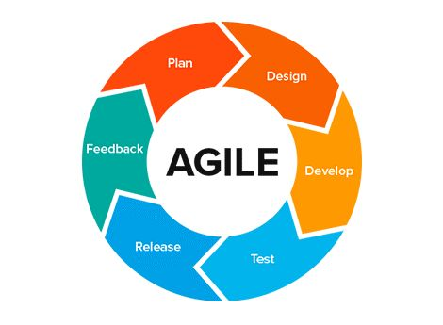Figure 1: Image of the Agile Development Methodology

This chapter will go on to give stages in the Agile process, starting with requirement gathering and system design followed by development, testing, and deployment. Agile approach also means that the platform is scalable and can be enhanced as and when required, irrespective of whether there are more need of integrating new features or adoption in new regions and hospitals.

The main tools and tech used in the development process are HTML5, CSS3, javascript, MySQL. Agile methodology helps project be efficient, adaptive and contented with the stakeholder.

**3.2 METHODS AND TOOLS**

**3.2.1 Research and Requirement Gathering**

The first flow of the methodology centered on soliciting requirements from key stake holders: the Ghana Blood Bank, the Sunyani technical hospital, the Sunyani municipal hospital and Sunyani SDA hospital, and other blood donors. To do so interviews, surveys, and document reviews were used to capture insights of existing challenges in blood donation and blood supply chain system. The basic aim was to find determined crucial essentials among donors as well as hospitals, which are required to donors and hospitals through requests, as well as various vendors engaged in different phases of the cycle such as book appointments of donors, educate process of donor, about blood donation schemes, educating lifetime techniques as a whole much more treating users of all intensity about its requirement.

**3.2.2 Stakeholder Identification:** The major stakeholders for the study were hospitals, the Ghana Blood Bank and the blood donors.

**3.2.3 Hospital**: The hospitals for the project considered were the following.

1. Sunyani Teaching Hospital
2. Sunyani Municipal Hospital
3. Saturday Adventist Hospital, Sunyani

**3.2.4 Ghana Blood Bank**: We first carried out an extensive review of the Ghana Blood Bank website, during which we identified several key requirements needed to develop a system. Through these researches, the training became the foundation on which to design the platform to be suitable for donors, hospitals, and blood banks demands.

**3.2.5 Requirement Elicitation Tools:** Functional and non functional requirements were collected using interviews, document analysis and observation.

**3.3 SYSTEM DESIGN**

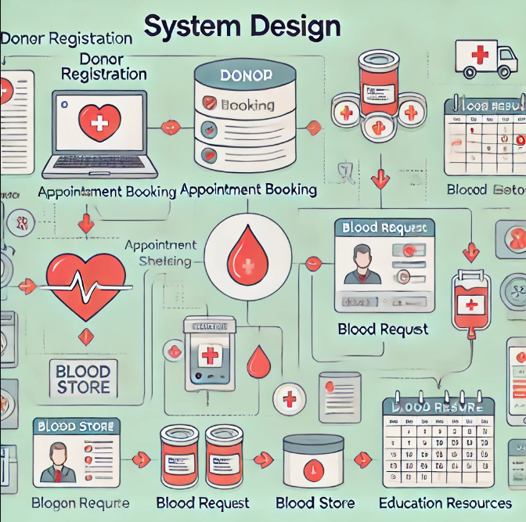We then descended to create a system based on the requirements gathered. This process, including defining architecture, creating database schemas, UI development, and outlining overall navigation as shown in figure 2. During this phase our main goals were to see that the system was user friendly, secure, and fluent for future needs.

Figure 2: This is an Image of the System design of the Blood Bank System.

**3.3.1 DATABASE SCHEMA**

**Table 1: DONOR TABLE**

|  |  |  |
| --- | --- | --- |
| **Field Name** | **Data Type** | **Description** |
| |  | | --- | | donor_id | | VARCHAR | |  | | --- | | Unique identifier for each donor | |
| |  | | --- | | full_name | | VARCHAR | |  | | --- | | Full name of the donor | |
| |  | | --- | | email | | VARCHAR | |  | | --- | | Email address of the donor | |
| |  | | --- | | phone_number | | VARCHAR | |  | | --- | | The contact number of the donor | |
| |  | | --- | | date_of_birth | | DATE | |  | | --- | | Date of birth of the donor | |
| |  | | --- | | gender | | ENUM | |  | | --- | | Gender of the donor (e.g., Male, Female, Other) | |
| |  | | --- | | blood_type | | VARCHAR | |  | | --- | | The blood type of the donor | |
| |  | | --- | | address | | VARCHAR | |  |  |  | | --- | --- | --- | |  |  | The residential address of the donor | |
| |  | | --- | | registration_date | | DATETIME | |  | | --- | | Date of registration | |

**Table 2: APPOINTMENT TABLE**

|  |  |  |
| --- | --- | --- |
| **Filed Name** | **Data Type** | **Description** |
| appointment_id | INT (PK) | Unique identifier for each appointment |
| donor_id | INT (FK) | Associated donor (foreign key) |
| full_name | VARCHAR | Full name of the donor |
| gender | **ENUM** | Gender of the donor (e.g., Male, Female, Other) |
| date_of_birth | **DATE** | Date of birth of the donor |
| region_city | VARCHAR | |  | | --- | |  |  |  | | --- | | Region or city of the donor | |
| appointment_date | **DATE** | Date of the appointment |
| appointment_time | **TIME** | Time of the appointment |
| donor_center | VARCHAR | Selected donor center |
| status | **ENUM** | Status of the appointment (e.g., scheduled, cancelled) |

**Table 3: BLOOD REQUEST TABLE**

|  |  |  |
| --- | --- | --- |
| **Field Name** | **Data Type** | **Description** |
| request_id | INT (PK) | Unique identifier for each blood request |
| hospital_id | INT (FK) | Associated hospital (foreign key) |
| blood_type | **VARCHAR** | Type of blood requested (e.g., A+, B-, O+, etc.) |
| quantity | **INT** | Quantity of blood requested (in pints) |
| urgency_level | **ENUM** | Urgency level (e.g., Normal, Urgent, Emergency) |
| requesting_hospital_name | VARCHAR | Name of the requesting hospital |
| hospital_address | VARCHAR | Address of the requesting hospital |
| region_city | VARCHAR | The region or city of the requesting hospital |
| contact_person_name | VARCHAR | Name of the contact person at the requesting hospital |
| contact_number | VARCHAR | The contact number of the contact person |
| request_date | **DATETIME** | Date and time of the request |
| status | **ENUM** | |  | | --- | |  |  |  | | --- | | Status of the request (e.g., Pending, Fulfilled) | |

**3.3.2 Architectural Design:** In a three-tier architecture, we had the presentation layer (User Interface), the application layer (business logic) and the data layer (database management).

**3.3.3 Database Design:** MySQL was used to develop the database and manage information regarding donor, hospital and blood stock level and donation history.

**3.3.4 UI/UX Design:** Tools like Figma were used to design blood donor and hospital staff design mockups and wireframes which allow a user friendly interface. The UI was created with simplicity of navigation as its first goal, while form designs, dashboards and so forth were made to be used easily.

**3.4 AGILE DEVELOPMENT PROCESS**

The system was developed using the Agile development methodology that provides the flexibility, usage of incremental enhancement at various stages of the project. They took the process into many sprints that lasted from 1 to 2 weeks. With this approach, there is an ongoing stakeholder feedback loop and you can adjust every sprint.

**3.4.1 Register as a Donor Page**

**Sprint 1:** We developed the donor registration feature in this sprint. What I strived to achieve was a user’s friendly sight that will aid potential donors to fasten up registering, putting in their personal information and creating accounts. This page also included functionality to track donation history.

**3.4.2 Book Appointment**

**Sprint 1:** Not only did we make the registering a donor feature, we also completed the appointment booking feature. Registered donors can also book appointments at nearby blood donation centers at their convenient times that they have preferred.

**3.4.3 Blood Request**

**Sprint 2:** In this sprint we worked on hospital blood request feature. It makes hospitals able to ask for particular blood types and delivers tools to let them keep a record of their blood stock level and directly communicate their requirements with the blood bank.

**3.4.4 Blood Store**

**Sprint 2:** Work was also underway on the bloodstock management module alongside the development of the blood request feature. With this new capability hospitals and blood banks can monitor and manage their blood inventory in an accurate and economical way, preventing both overstocking and shortages.

**3.4.5 Education Resources on Blood Donation and Blood Bank**

**Sprint 4:** This sprint saw us integrate the educational module. Resources provided by this feature are dedicated to raising public awareness of the importance of blood donation. Content comprises the details about eligibility criteria, procedure of donation, and how blood banks are important to save lives.

**3.4.6 Final Testing and Optimization**

**Sprint 5:** The testing, debugging, and squeezing out of extra optimization the platform needed before release was done in that last sprint. For all other features, we ran usability tests including donor registration, appointment booking, managing blood requests, tracking blood storage, and educational resources before deployment making sure security as well as functionality were fully tested.

This sprint based development meant that the platform could be built, tested, and improved iteratively with feedback from end users.

**3.5 TECHNOLOGY STACK**

It was built upon a blend of web technologies meant to enable scalability, security, and response.

**Frontend:** HTML5, CSS3, and JavaScript were used to develop a responsive as well as interactive user interface.

**Backend:** As for the server side logic, I created them up using PHP to both handle requests, manage sessions, and protect data transactions.

**Database:** The database management system for information related to blood donors, donation history, hospital request and blood inventory is MySQL.

**3.6 TESTING AND QUALITY ASSURANCE**

The system was first thoroughly tested in terms of functionality and security, before being deployed. Different testing methodologies were used:

**Unit Testing:** Donor registration and hospital requests were tested separately to guarantee it works the way it should.

**Integration Testing:** The first phase was to verify that everything ran smoothly between various system parts like database, database serving, and user interface.

**User Acceptance Testing (UAT):** Addressing the perceived gap, feedback from blood donors, hospital staff and the Ghana Blood Bank was sought to improve the platform.

**3.7 DEPLOYMENT**

After development and testing were complete the platform’s implementation occurred. It was developed in particular for desktop, but the main thought was to make the possibility of using it for everyone.

**3.8 MAINTENANCE AND FUTURE ENHANCEMENTS**

The last stage is concerned with the ongoing upgrade which ensures the system is updated with new securities, others, the fixing of new bugs and updates. They might include further enhancements that would include employing machine learning techniques, for example, to predict likely blood deficits and, therefore, identify potential donation patterns.

**3.9 TOOLS AND TECHNOLOGIES**

**Frontend Technologies:** HTML5, CSS3, and JavaScript

**Server-side:** PHP

**Database Management System:** MySQL

**Version Control:** As for the practices, we will be discussing Git and GitHub as the tool of choice for cooperative work in the development sphere and the process of proper versioning.

**CHAPTER 4**

**DESIGN AND IMPLEMENTATION**

**4.0 INTRODUCTION**

In order to improve blood collection and distribution efficiency, we need to create a reliable and user intuitive blood donation management system. The aim of this system is to provide a seamless way for donors, hospitals and administrative staff communicate, providing both donation and request flow methods that are both smooth to undergo and accessible to everyone involved.

In the implementation phase we discuss how to come up with an intuitive user interface (UI) that makes navigation easier, improves user experience and creates more usability. Special care is taken in the design of each page of the system so that each page is given to address each user’s requirements, and also wanting that the design of the system in overall is very cohesive as well as visually attractive. The system improves communication effectiveness and operational efficiency simply by increasing ease of use and attractiveness of layout.

**4.1 HOME PAGE OVERVIEW**

The Blood Bank platform’s Home page is essentially the central nucleus where users will get a look into all the features and how they work. It's designed to get them open and up to running essential services in as quick a time as possible.

**Key Features**

**Quick Navigation Links:** Links occupy a leading position on the Home page and lead users directly to important sections such as:

**Donor Registration:** It's so easy to register as a life saving donor.

**Appointment Booking:** You can effortlessly schedule your blood donation appointments.

**Blood Request:** Hospitals can quickly send in requests to blood units.

**Blood Store:** Monitor and manage blood supply efficiently.

**Educational Resources:** There you will find useful information on blood donation and its impact in the society.

**Contact Us:** If you have questions, or need help, we are here to assist. Here is a quick navigation image below with your link.



Image 1: Image of the Quick Navigation Links

**Statistics Section:** What’s compelling on the Home page are the alarming statistics of the urgent need for blood donations.

**Blood Donation Impact:**

5,000+ blood donations facilitated through our platform.

1,200 Units Required to Satisfy Current Demands

800+ Lives Saved Due to the Generosity of Donors.

Here’s the image underneath which shows the statistics section in the homepage.

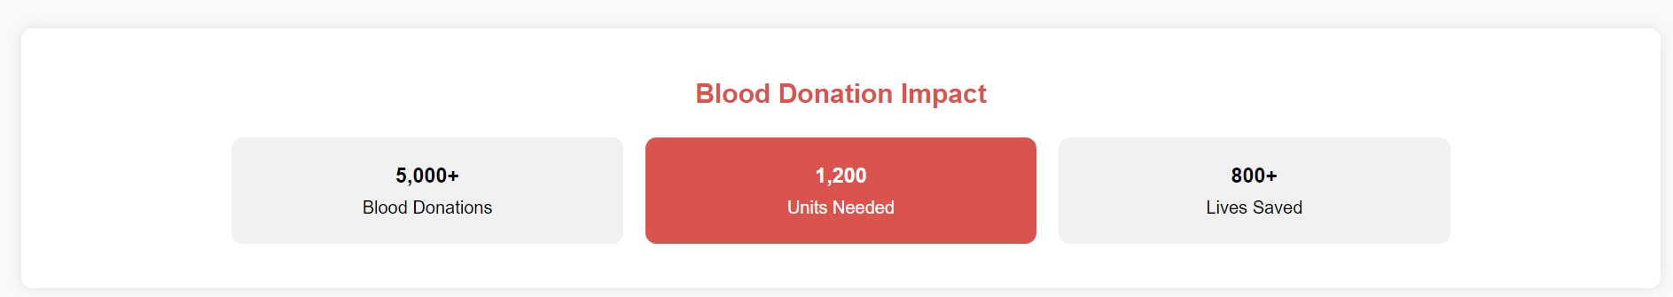

Image 2: Image of the Statistics section of the Home page

**Blood Donation Banners:** Blood Donation Banners 1, 2, and 3 are run with dynamic visuals that grip visitors with their presence and inspire them to come forward to donate blood. Banners are shown on the home page in images 3,4, and 5.

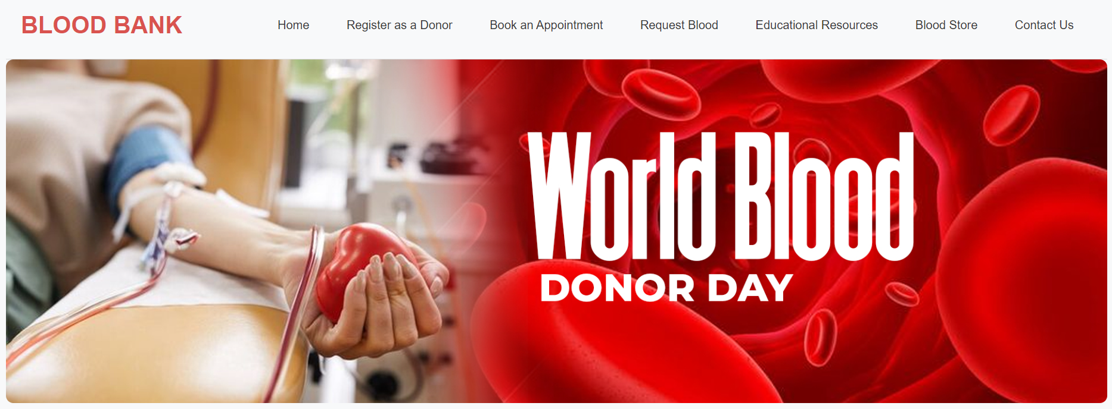

Image 3: This image is the Blood Donation Banner 1 of the Home Page.

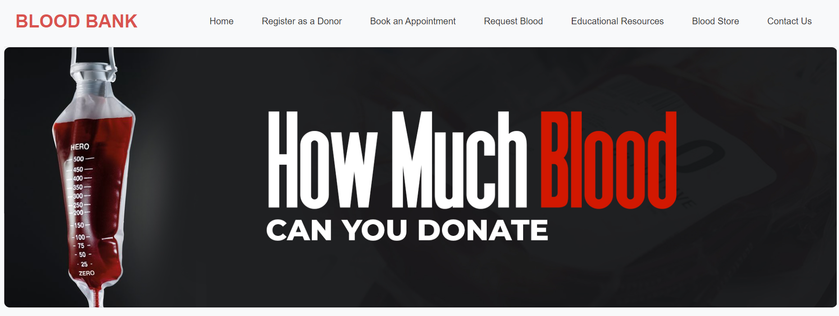

Image 4: This image is the Blood Donation Banner 2 of the Home Page.

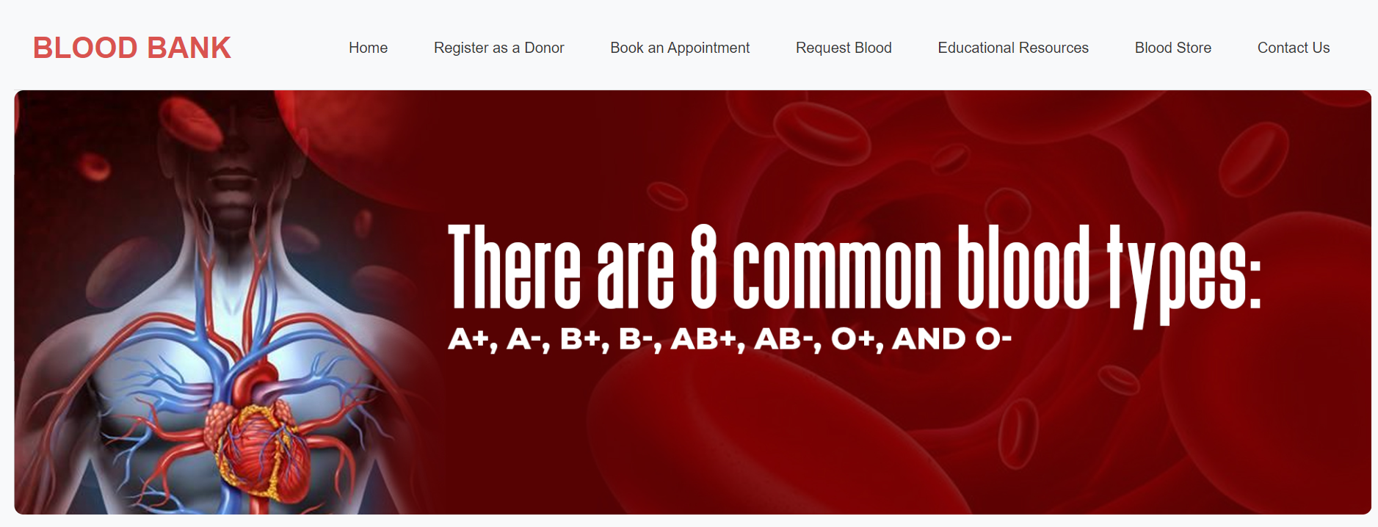

Image 5: This image is the Blood Donation Banner 3 of the Home Page.

**About Us Section:**

**About Us**

The Blood Bank platform solves the important problem of blood shortages through the interconnection of donors, recipients, hospitals and blood banks. To make sure there is life saving blood readily available to those who need them, we strive to create a smooth, efficient system.

**Our Mission:** Our mission is to develop and operate a dependable, scalable platform that facilitates blood donation and distribution, so that patients receive the critical blood they need, as soon, as possible.

**Why We Exist:** Treatment of serious diseases like cancer and transplant procedures depend on transfusion patients. We pledge to help raise awareness, make donation easy, and to provide blood as quickly as possible.

**Our Core Values:**

**Compassion:** Being a product rooted in the human responsibility to help the other.

**Integrity:** All transactions being transparent and honest.

**Innovation:** Using technology to create a good solution.

**Community:** Using the power of our collective to save lives. Below is an image showing which part of the homepage our 'About Us' lives on.

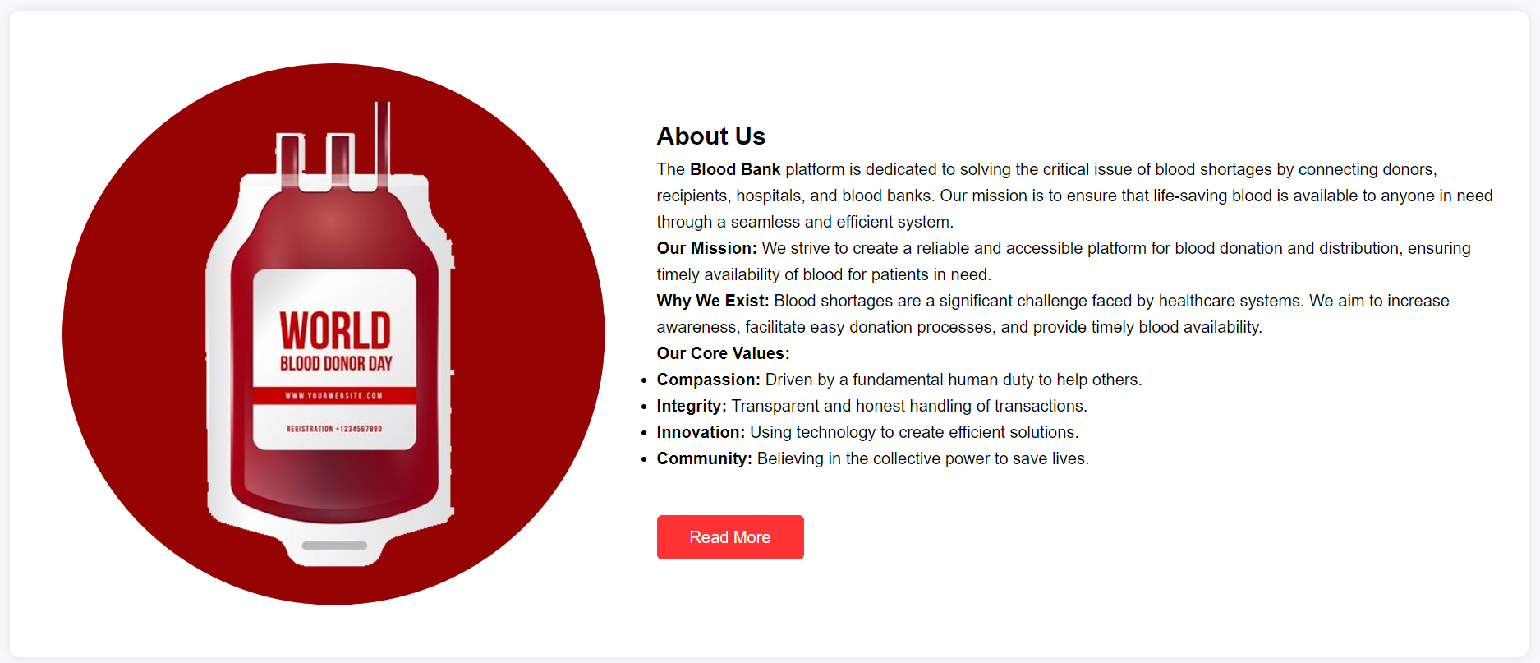

Image 6: This image is in the About Us section of the Home page.

**Our Services Section:**

**Our Services:**

**Blood Collection:** To support efficient and secure blood extraction from blood donors to fulfill different medical needs.

**Donation Drives:** Working with the community to help promote and encourage blood donations in our surrounding communities.

**Blood Testing:** Guaranteed safety and compatibility of donated blood with in depth analysis.

**Blood Storage:** Finding a meaningful way to ensure proper storage to make sure blood quality and readiness for emergency situations.

**Emergency Supply:** Delivery of blood when it is most needed.

The "Our Service" section of the homepage is displayed in image 7 below.

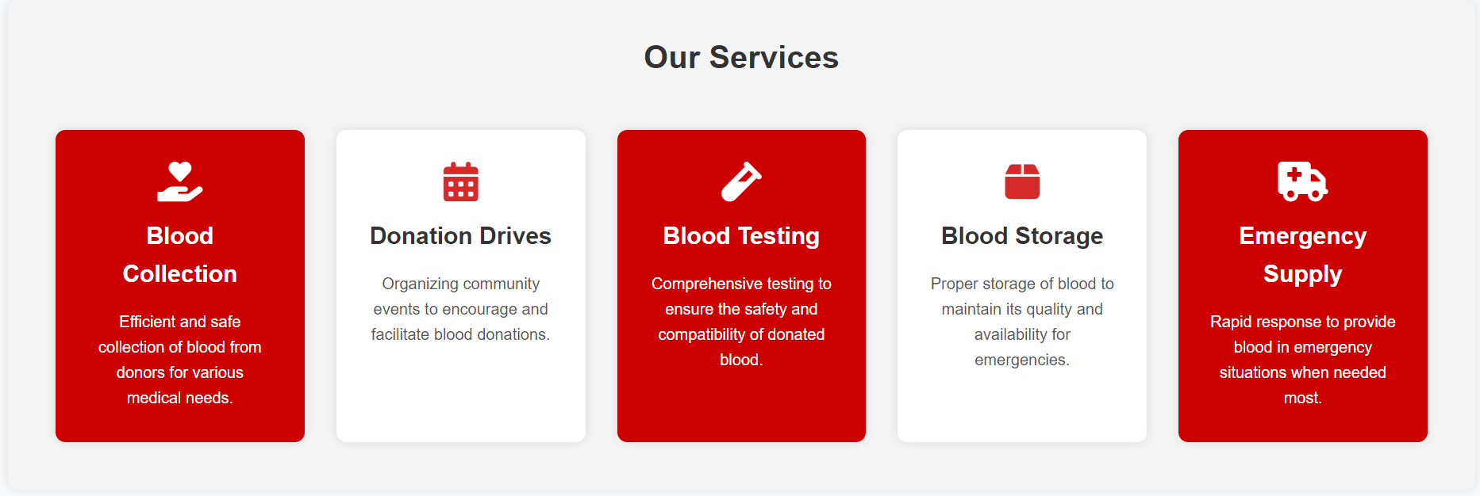

Image 7: This image is the Our Service section of the Home Page.

**Donate Now Section:**

**Donate Now**

Donate and save lives. Your contribution can change someone’s world. We can all fight blood shortages and make sure every patient receives the care they need. Details of how to Donate Now! can be found in Image 8 on our homepage.

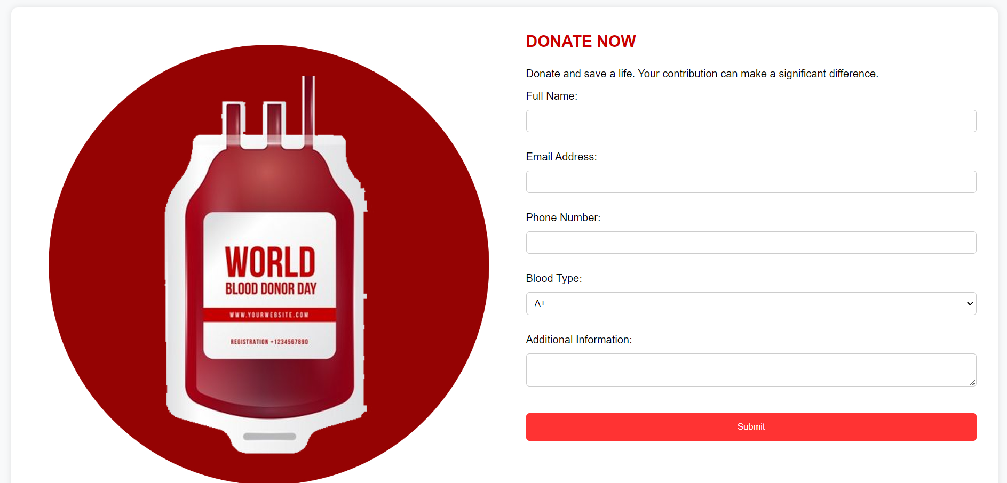

Image 8: This image is in the Donate Now section of the Home Page.

**Footer Section:**

Essential links and information will appear in the footer section such as:

**Contact Information:** Phone numbers, email and social media links.

**Privacy Policy:** Other information on how your information is processed and safeguarded.

**Terms of Service:** Rules for using our platform. The following is an image of the footer part of the homepage.

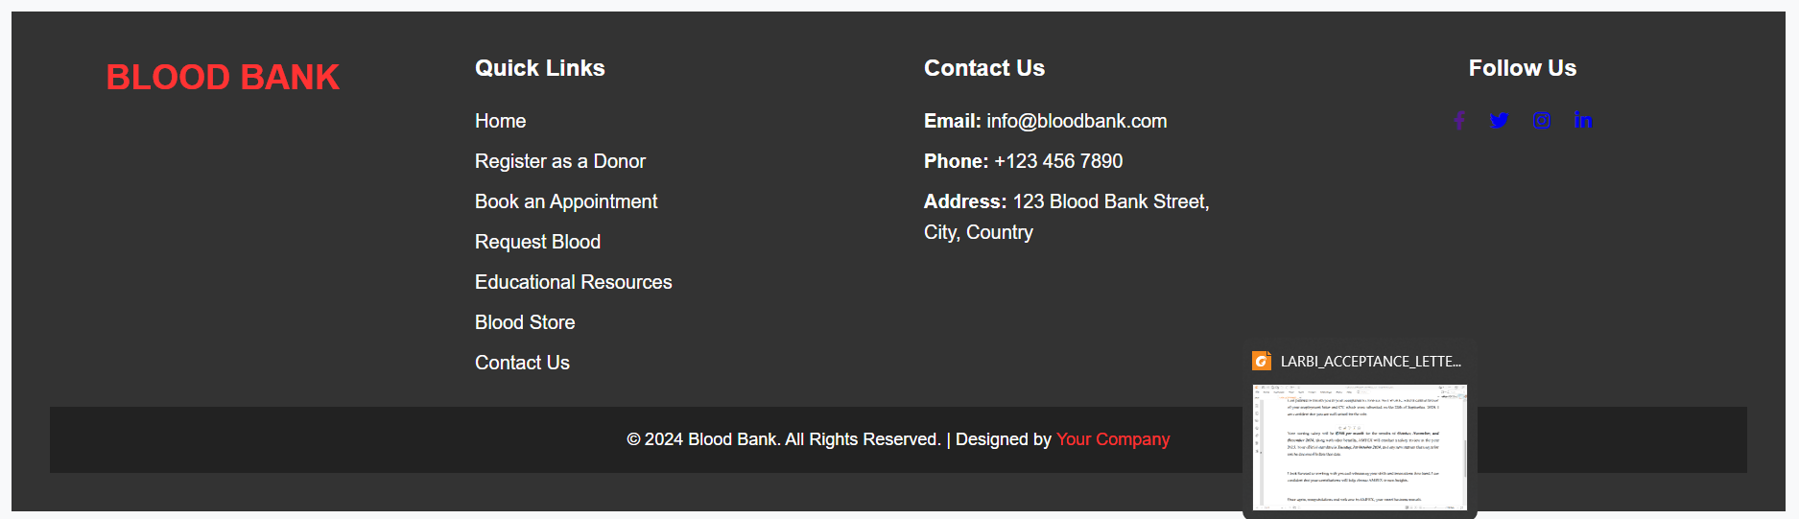

Image 9: This image is the footer section of the Home Page.

**4.1.1 REGISTER AS A DONOR PAGE**

It enables potential donors to just fill out their details and become part of the blood donation community with a click of a button. It puts special focus on clarity and simplicity: the design makes users sail smoothly through the registration process and does not loose anything that is important. Here's an image of what is shown in the banner section of the 'Register as a Donor' page:

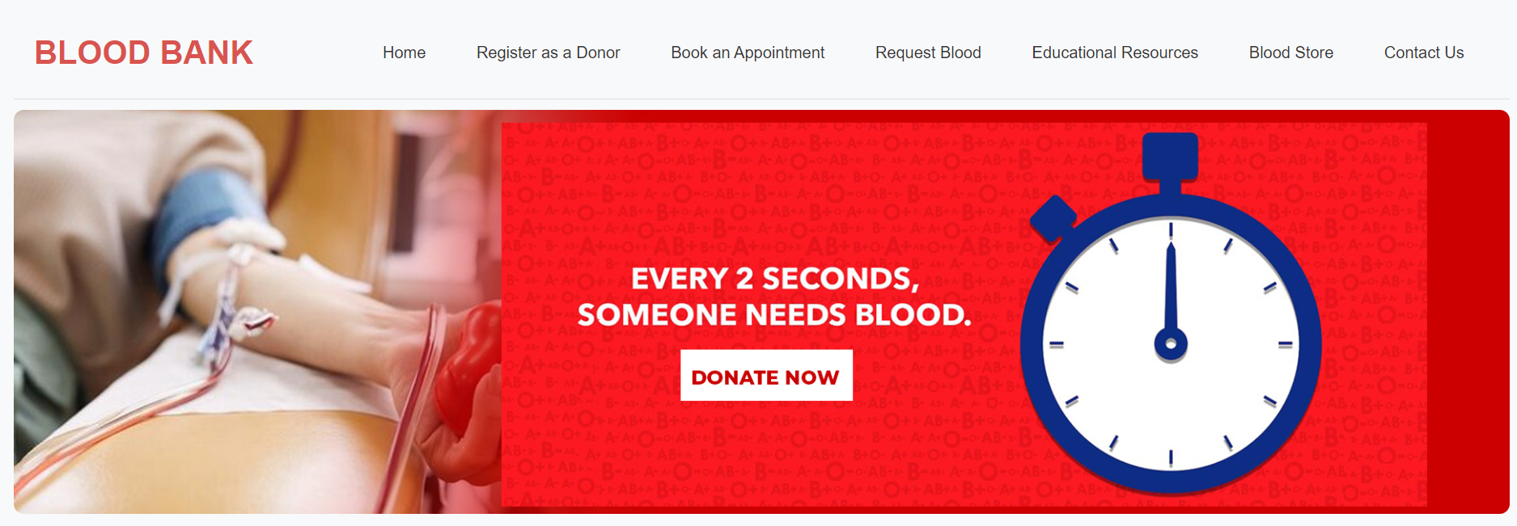

Image 10: This image is the Banner section of the Register as a Donor Page.

**BENEFITS FOR DONORS**

Learning about why blood donation is important can motivate people to do this vital lifesaving task. Here are some of the main benefits of registering as a donor:

**Free Health Check-up (90%):** Donors undergo free health screenings before donating to make sure that their well being is taken care of.

**Helps Save Lives (100%):** A lifesaving blood donation has the ability to save the lives of multiple patients with the ability to need your life saving blood.

**Reduced Risk of Heart Disease (75%):** Threats of cardiovascular diseases are reduced by low iron levels, which are in turn lowered by consistent donations.

**Burns Calories (85%):** Donating blood helps you burn calories and improves your fitness.

**Improves Mental Health (65%):** Helping out with a life saving cause will make you feel well, full of confidence. The benefits section of the donor registration page is shown on Image 11.

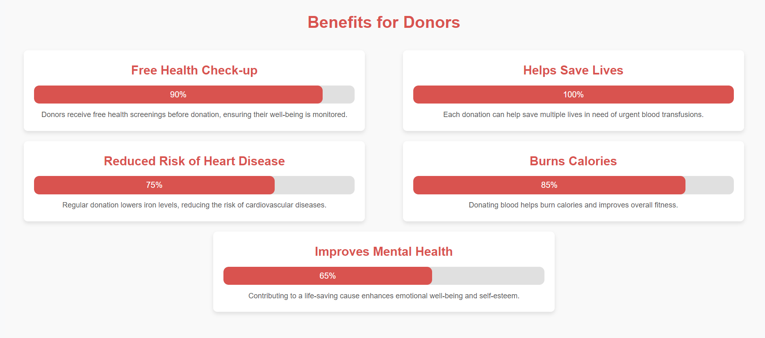

Image 11: This image is the Benefits section of the Register as a Donor Page.

**REGISTRATION FORM**

The Registration form is designed for people who are interested in donating their blood to save lives. It is made up of the Full name section, Email, Phone Number, Date of Birth, Gender, Blood Type, and Address. The image below shows the Registration form of the register as a donor page.

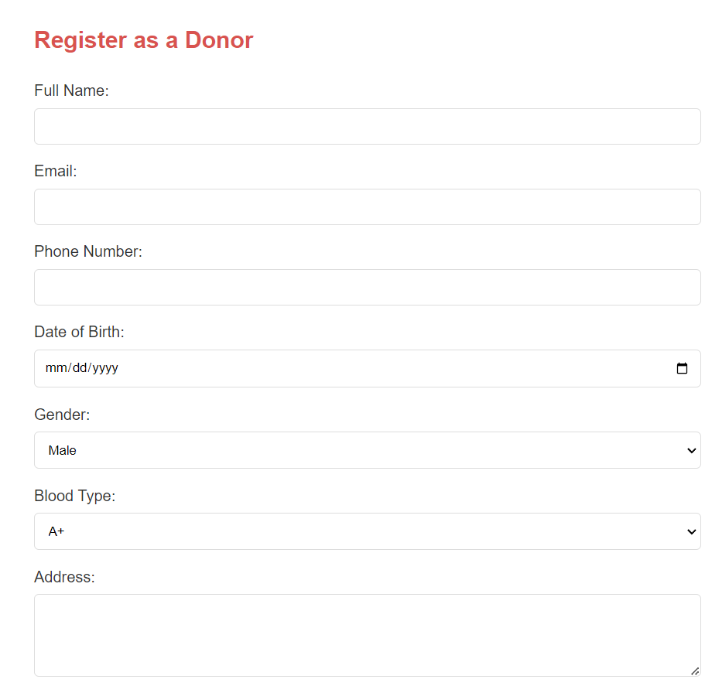

Image 12: This image is the Registration form section of the Register as a Donor Page.

**LATEST NEWS**

Stay up to date with what’s happening in our evolving blood donation community:

**News 1: Major Blood Drive Event This Weekend**

This weekend join us for a huge blood drive event. It all matters. Every donation makes a difference!

**News 2: New Blood Donation Center Opening**

Just excited to announce our new blood donation centre is opening!

**News 3: How Blood Donations Save Lives**

Turn your contribution into how someone’s life can change..

**News 4: Volunteer Opportunities Available**

Learn more about how to make a difference! Learn about our volunteer opportunities available today.

The following image displays the news section from the donor registration page.

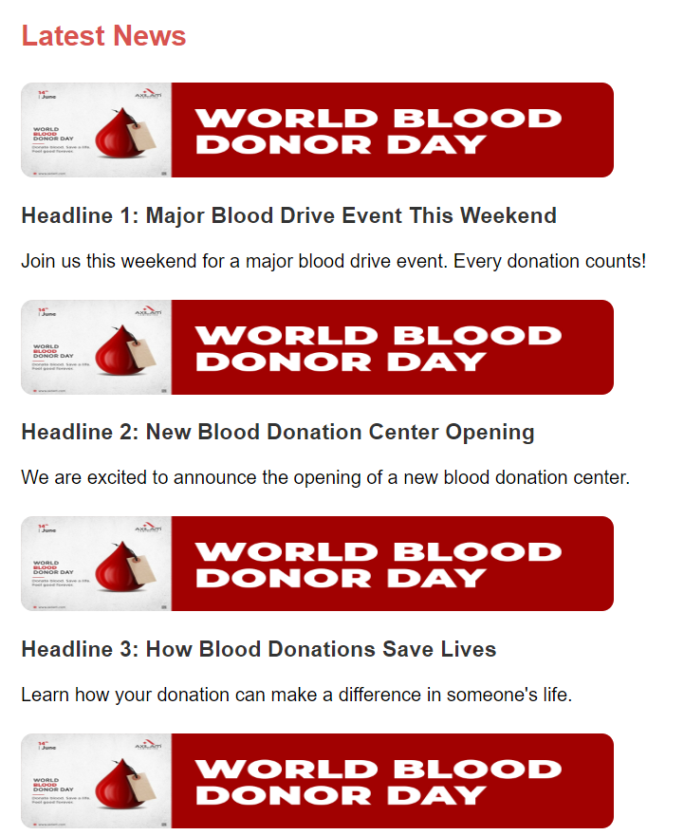

Image 13: This image is the News section of the Register as a Donor Page.

**4.1.2 BOOK AN APPOINTMENT PAGE**

The Appointment Booking is designed to be a simple experience for someone to make an appointment to donate blood. It has an easy to use interface, lower complexity in appointment management without compromising choice of date and time of appointment and donor centre. The appointment form on this booking page can be seen below.

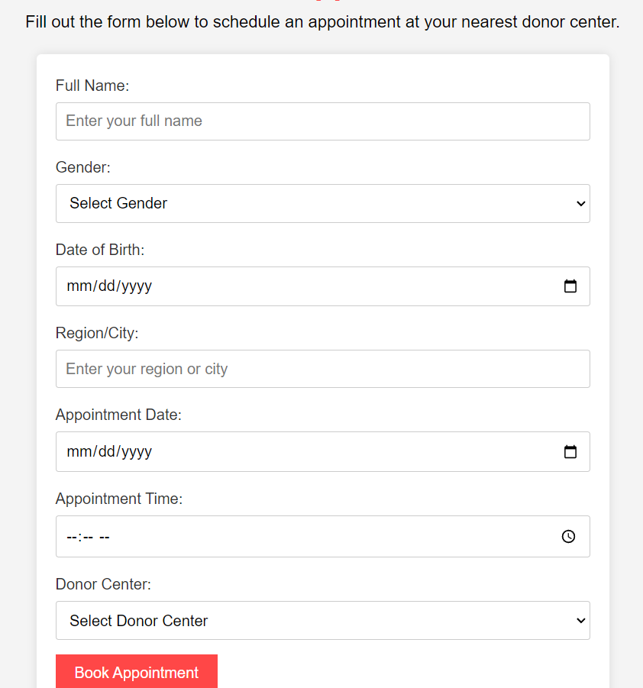

Image 14: This image is the Book Appointment form of the Appointment Page.

**4.1.3 REQUEST BLOOD PAGE**

The facilities included are the Blood Request page where hospitals and health care facilities can make blood supply requests as shown in images 15 and 16. It has a simple form to enter blood type, amount, and required time that increases the rate of capturing all relevant details considerably.

**Select the Hospital to Request Blood**

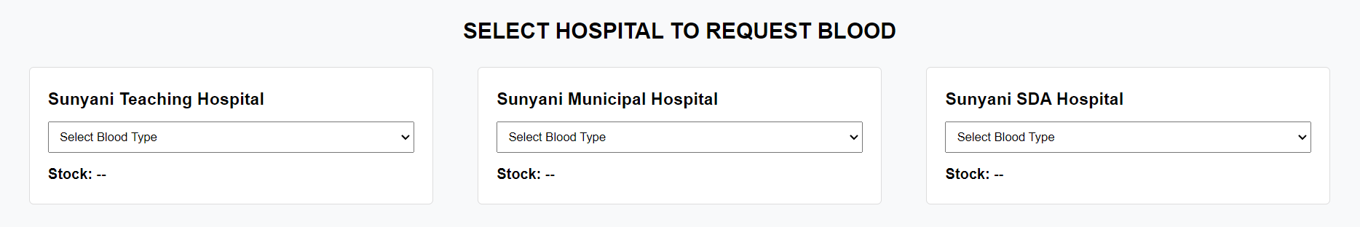

Image 15: This image is the Blood Stock Preview of the Request Blood Page.

**Request Form**

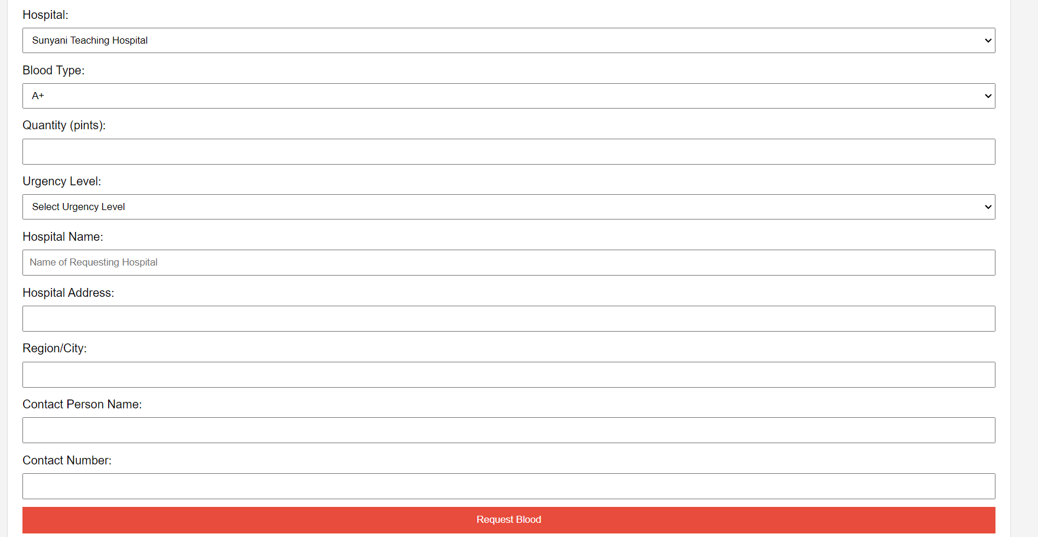

Image 16: This image is the Request Blood Form of the Request Blood Page.

**4.1.4 EDUCATIONAL RESOURCES PAGE**

As with the “Educational Resources” page of the site, the user is to receive vital information regarding blood donation and its impact, as well as related topics. Image 17 below can also be used to show user accessibility whereby the users can easily get around a set of articles selected.

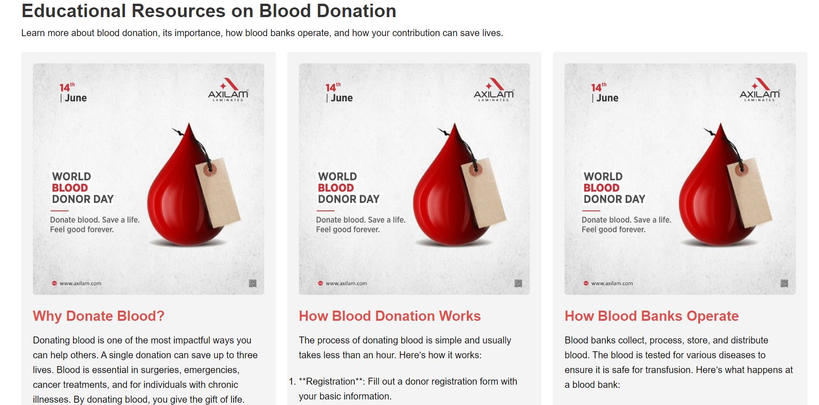

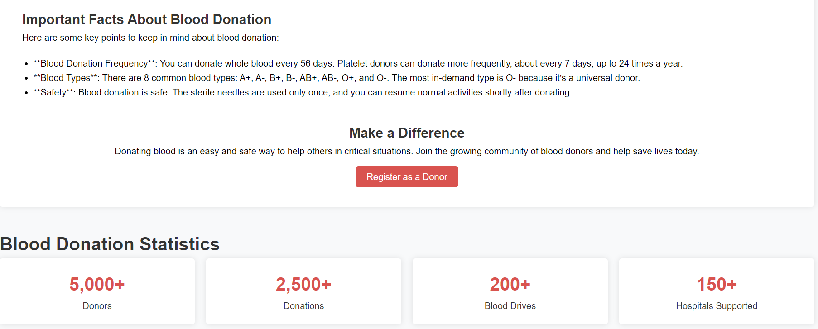

Image 17: This image is in the Educational Resource Section of the Educational Resources Page.

**4.1.5 BLOOD STORE PAGE**

This page helps to track and control the blood supply. Some of the features embodied in the design are; blood stock updates, where Hospitals are updated on available quantities in real time for better decision making. The next section displayed in the video is the blood storage section; please view Image 18 below.

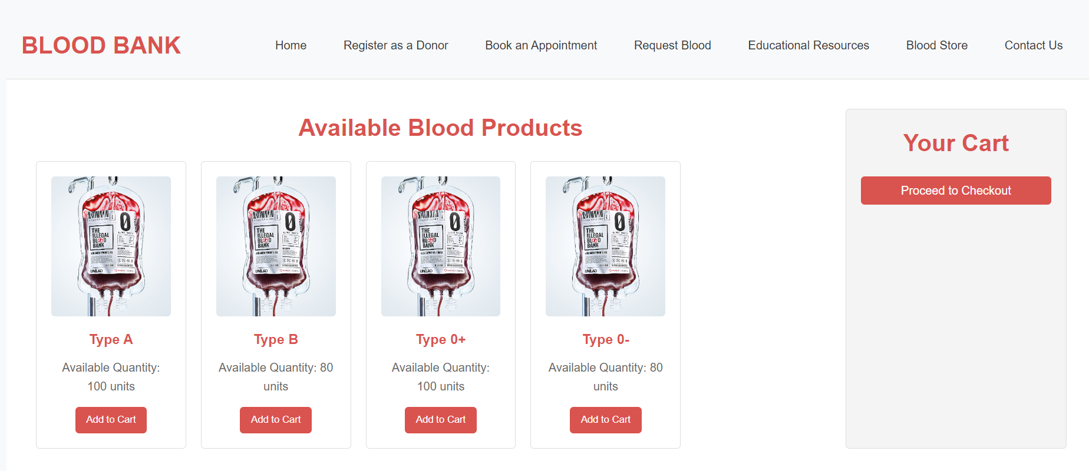

Image 18: This image is the Blood Store section of the Blood Store Page.

**4.1.6 CONTACT US PAGE**

Another page created to effectively allow user and system administrator to easily communicate is the Contact Us page. It provides important communication information in addition to a simple feedback and/or message submission box guaranteeing that all worries will be addressed immediately. Here is an image of Contact Us page.

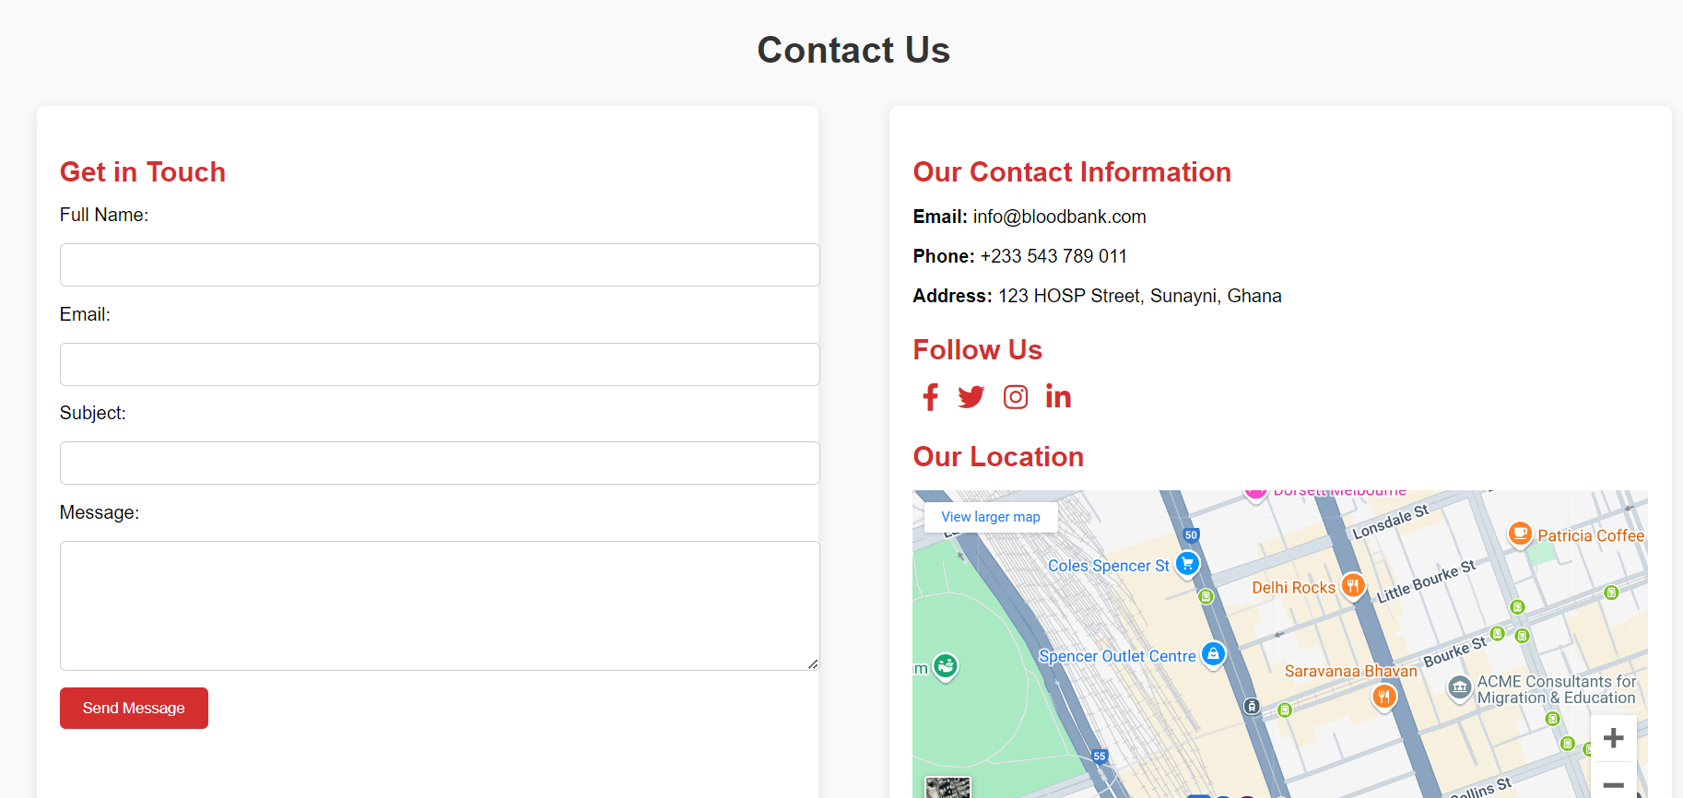

Image 19: This image is the Contact Us page of the Contact Page.

**CHAPTER 5**

**RECOMMENDATION AND CONCLUSION**

**5.0 INTRODUCTION**

There is, therefore, need to develop a sustainable blood donation management system as a way of addressing the challenges that relate to blood shortage as well as the distribution of blood in Ghana. The envisioned web platform aims at enhancing the blood donation model, enhancing communication among different parties, as well as the efficient management of blood. These will include the following; this platform will connect blood donors, Hospitals ,and the Ghana Blood Bank as a single platform that enhances life-saving measures. Applying ASDM as the name suggests enable our development team to incorporate the principles of flexibility and client collaboration and improvement on each phase of the development life cycle. The present paper is a panoramic view which highlights methodology and design aspects, implementation strategy inclusive with highlighting technological aspects alongside features and possible areas of improvement.

**5.1 RECOMMENDATIONS**

**Continuous Stakeholder Engagement:** Continuously engage with blood donors and hospitals and the Ghana Blood Bank. To make the platform effective, you need to schedule regular feedback sessions that enable the platform to adapt to user’s needs by implementing suggestions for improvement.

**Enhanced User Education:** Write deep educational material on the blood donation process, eligibility requirements, and it’s importance. Make sure they can easily be found on the platform to provide inspiration and clue as to what to do for potential donors.

**Regular System Updates:** Set up a pattern of system updates and maintenance to hold peak performance, secure system, and comply with healthcare, technology standards.

**Data Analytics for Predictive Insights:** Use software and applications to monitor the trends involving blood donation, and hospital’s repeat request. This helps in predicting the shortage, improves the efficiency of blood supply chain and also comes up with solution concerning some typical problems.

**Mobile Accessibility**: Build a separate mobile application or see to it that the web platform is perfectly responsive on mobile devices. That would be helpful for users on the go and let them more easily donate.

**Partnerships with Community Organizations:** Organize donation campaigns with the relevant organizations and institutions of the community and local companies. It can also increase community engagement, improve the blood donation activities of the community.

**Incorporate User Feedback Mechanism:** Design a system that enables users to provide feedback, and provide an efficient feedback system within the platform for such users to do so. However, it could be as simple form, or else as a dedicated section in which users exchange their experiences and insights.

**5.2 CONCLUSION**

The blood donation management system built for Ghana represents an important step in addressing the inefficiencies and low blood collection and distribution effectiveness. Using the Agile development methodology this project helped create an adaptable design process whereby the work could be adjusted based on stakeholder input.

The design of the platform features was seamlessly integrated into the platform and into blood donors, hospitals and the Ghana Blood Bank. Firstly, it is user friendly as it is easy for navigation and also very visually attractive, which makes it easy to navigate and increase user experience. Educational resources, fast navigation links, and figures that spark awareness for blood donation needs and motivate readers into actions are found on the home page.

These recommendations are crucial for the system to endure, and to ultimately become sustainable, as the system progresses. In tackling blood shortages in Ghana, the platform will really be instrumental by encouraging stakeholder collaboration and continually adapting to user needs. Ultimately, this effort will save lives, improve healthcare outcomes.

**REFERENCES**

Agyeman, A. A., & Osei, E. (2019). Challenges and opportunities for blood donation in Ghana: A review. “Journal of Blood Medicine”, 10, 45-52. https://doi.org/10.2147/JBM.S181234

Ghana Health Service. (2021). “Annual report on blood donation and transfusion services in Ghana.” Retrieved from [http://www.ghs.gov.gh] (http://www.ghs.gov.gh)

Kyeremeh, K., & Adjei, A. (2018). The role of technology in enhancing blood donation processes: A case study of Ghana. “International Journal of Health Systems and Services”, 3(1), 25-34. https://doi.org/10.1016/j.ijhss.2017.12.001

Osei-Akoto, I., & Owusu-Agyei, S. (2020). Public awareness and attitudes towards voluntary blood donation in Ghana: Implications for policy and practice. “BMC Public Health”, 20, 1234. https://doi.org/10.1186/s12889-020-09291-5

World Health Organization. (2020). “Global status report on blood safety and availability 2019.” Retrieved, from[https://www.who.int/publications/i/item/9789241566116] (https://www.who.int/publications/i/item/9789241566116)

Agyeman, D. A., & Osei, A. (2019). Challenges in Blood Donation: Perspectives from Blood Banks in Ghana. *Journal of Blood Medicine*, 10, 45-52.

Ghana Health Service. (2021). Annual Report on Blood Donation and Transfusion Services. Accra: Ghana Health Service.

Kyeremeh, A., & Adjei, C. (2018). Public Awareness and Blood Donation in Ghana: A Review. *African Journal of Health Sciences*, 31(2), 120-128.

Osei-Akoto, I., & Owusu-Agyei, S. (2020). The Impact of Blood Shortages on Patient Care in Ghana. *BMC Health Services Research*, 20(1), 300.

World Health Organization. (2020). Global Status Report on Blood Safety and Availability. Geneva: WHO.

American Red Cross. (2019). *The Importance of Blood Donation: A Guide for Healthcare Providers*. Retrieved from [Red Cross website] (https://www.redcross.org)

Blood Centers of America. (2020). *Increasing Blood Donation Through Education*. Retrieved from [BCA website] (https://www.bloodcentersofamerica.org)

European Blood Alliance. (2021). *Communication Strategies for Blood Donation*. Retrieved from [EBA website] (https://www.europeanbloodalliance.eu)

Health Affairs. (2020). *The Role of Automation in Healthcare Logistics*. Retrieved from [Health Affairs website] (https://www.healthaffairs.org)

Institute of Medicine. (2017). *The Future of Blood Donation: Innovations and Improvements*. National Academies Press.

World Health Organization (WHO). (2018). *Global Status Report on Blood Safety and Availability*. Retrieved from [WHO website] (https://www.who.int)